Shabbos Stories for
PARSHAS re’eh 5782
Volume 13A, Issue 53 – 30 Menachem Av 5782/August 27, 2022
Printed L’illuy nishmas Nechama bas R’ Noach, a”h

For a free subscription, please forward your request to keren18@juno.com
Past stories can be found on the website ShabbosStories.com

The Unique Beauty
Of Eretz Yisroel

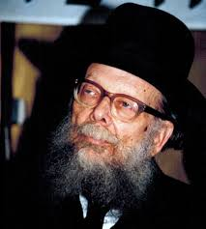

Rav Shlomo Wolbe, ZT”L, a very soft-spoken man. In his quiet manner and measured words, whose messages impacted thousands through profound talks and prolific writings. Rav Mordechai Kamenetzky visited him one day and was discussing a bit about his Swedish roots and European topography.
They came to the subject of the Swiss Alps, and Rabbi Kamenetzky mentioned that he heard in the name of the Brisker Rav, ZT”L, the revered mentor of Rav Wolbe’s generation, that when the Moshiach will come, he will transport the Swiss Alps and transplant them in Israel. Upon hearing Rabbi Kamenetzky say those words, Rav Wolbe’s tranquil demeanor changed immediately. He stood up to his full height with fire in his eyes.
“The Brisker Rav could never have said that!” he boomed. Rav Wolbe continued with a soliloquy whose passion was palpable: “There are no mountains as beautiful as those in Tzfas, there are no lakes as beautiful as the Kineres, and there is no city that sparkles like Jerusalem! Mashiach need not bring anything here! It is all here!”
Comment: Moshe Rabbeinu begins Parsha Va’eschanan by telling the Jewish people how he pleaded with the Hashem to let him see the Land of Israel. We find that Moshe was pleading to enter as an expression of the Jew’s eternal longing, appreciation, and passion for Eretz Yisrael. Moshe’s statement, (Devarim 3:24) “Hashem, you have just started to show me the power and the glory” was though Moshe understood that all the miracles, the splitting of the sea, the miraculous manna, the water from the rock, were only a prelude to Eretz Yisrael and would not compare to the greatness attainable from the majestic experience of entering the land.

Reprinted from the Parshas Vaeschanan 5782 email of Torah Sweets.

Story #1287
The Farmer’s Unmarried Daughter
From the desk of Yerachmiel Tille
Editor@ascentofsafed.com

Yankel the peasant was a farmer by choice, and a wealthy one at that. Although he did not know how to read and write, he did, however, know almost everything there was to know about farming. That is how he had been able to work his fields to yield their maximum and enrich their master.
Yankel did not want his sons to grow up ignorant like he was, unable to read the simplest prayers. He tried to hire a tutor to come to his home but could not find one. Instead, he sent the two boys to a nearby town which boasted a good cheder (elementary-school level) and yeshiva. Shimon and Levi dedicated supreme efforts to becoming true Torah scholars and soon won a name for themselves as the iluyim-geniuses of their yeshiva. When the boys chanced once to hear the Baal Shem Tov speak, they became ardent admirers of him and traveled frequently to hear more from him and bask in his holy aura.
“Why are you always going to Mezibuz?” the father would ask the boys, not understanding what could draw his sons to that distant city.
“We want to visit the wise man who lives there, the famous Baal Shem Tov.”
"Why is he considered so wise?” their farmer father would insist on knowing. “Can he plow? Does he know anything about planting? About crops? Weather?”

He (the Baal Shem Tov) Knows
About Everything Under the Sun
The sons tried to relate to their father in a language that he was familiar with “Yes Father,” they would reassure him. “The Baal Shem Tov knows about everything under the sun, including farming.” This answer would usually satisfy Yankel and he let his sons visit the tzadik of Mezibuz.
One time, however, his curiosity overcame him. “This time,” he announced, “I am going to Mezibuz myself. Why should I not see this wise man with my own eyes?”
Yankel prepared for the trip, taking along many gifts for the rabbi. He arrived at his destination and was admitted into the tzadik’s presence. “My sons tell me that you are a wise man. That you know everything there is to know about farming. Is this true?”
The Baal Shem Tov launched into a detailed account of all the fields the farmer owned and their exact boundaries. He then described exactly what Yankel had planted the past season in each of these fields. The peasant could not help being impressed with the detailed knowledge.
He decided that his sons were correct; this rabbi was indeed a learned and wise man. But if so, he thought to himself, then shouldn’t the Baal Shem Tov also be able to advise him on what to plant in the coming season? That requires a special expertise.

The Farmer Gets Advice on What He Should Plant
The Besht obliged, giving him precise information about what he should plant, where and in what amounts. He then dismissed the peasant with a friendly nod of his head.
Yankel returned home and, recalling what the Baal Shem Tov had advised, followed his instructions to the letter, planting wheat where the tzadik had said and oats where the tzadik had advised. Summer came and with it the harvest. When Yankel had gathered in all his grain and fruit he found that the same fields had yielded many times their former amount. He could not help being impressed with the Besht’s vast knowledge and foresight.
Yankel became a staunch admirer of the Baal Shem Tov, traveling to Mezibuz whenever he had any questions. Of course, his interest lay in a different area altogether from that of his sons, but still, they all shared a mutual admiration for the tzadik.
Years passed and the peasant’s daughter became of age. He had many offers for her hand -was she not the daughter of a wealthy man and the sister of two noted scholars?

Desires the Opinion of the Besht as
To Whom His Daughter Should Marry
Yankel felt that he could not take such a major step without consulting the wise man of Mezibuz. He listed the names of each prospective suitor and when he had accumulated many names, decided it was time to consult the rebbe.
Tell me, honored rabbi, who on this list do you consider the most eligible suitor for my daughter? Many of these young men have wealth or family to recommend them, but I dare not make the decision alone.”
The Besht took the list from his hand and pored over it. Then he shook his head and gave it back to Yankel.
“None of these men are destined for your daughter," he declared. "Return home and send me your two sons. I will find a suitable match for your daughter and he will accompany the boys home.
Yankel did as he had been told. He returned home and sent his boys instead.
When Shimon and Levi arrived, the Besht took the youths with him and the three traveled to a distant city. The word spread about the Baal Shem Tov’s presence, and the townspeople prepared a lavish reception. Everyone came to pay his respects, from the trustees to the simplest cobbler.

Asks for the Help of the Town’s People
When the people had all gathered in the large hall, the Baal Shem Tov revealed the purpose of his visit. “I want all your cooperation, my good people,” he announced. “I am looking for a certain young man, Shmerel the son of Velvel Itzik and Sarah Beila. If he is here today, let him step forward.”
Hundreds of eyes scanned the crowd but no one moved. The Baal Shem Tov continued, “Is there anyone here who knows where this young man lives?”
Again all eyes roved around the hall but no one spoke up. “I will be remaining here for several days. If anyone can trace Shmerel and bring him to me, I would be most grateful.”
Everyone wanted to be helpful but no one could recall such a name of a person living in their town. Several days went by but not a single clue turned up.
Meanwhile Rosh Chodesh came, which gave the happy townspeople another occasion to gather under one roof for a New Moon festive meal, and host the eminent Baal Shem Tov who had obliged them by gracing their city. A large meal was prepared in his honor and rows of tables were laid with snowy tablecloths. Fresh white challahs were put at each place.

A Wild Youth with Unkempt Hair
Just as the people were about to wash and take their places, a wild youth with unkempt hair, dressed in dirty smelly rags, ran in and grabbed one of the dainty challahs. He ran out before people realized what was happening.
“Hey Shmerel!” someone shouted. “You, son of Velvel Itsik and Sora Baila, you come right back and return that roll.”
Suddenly everyone froze. That was the name they were to be on the lookout for! Could this really be? What could the Baal Shem Tov possibly want with such an uncouth and vulgar young man? He and his family enjoyed a reputation of being slothful, dirty, coarse and low.
They decided that this was a matter they would leave for the Besht to decide for himself. “Fine!” the Baal Shem Tov exclaimed. “Grab the boy. Wash him well and have him dressed up. Then bring him here to me.”
When Shmerel saw he was being pursued, he ran away as fast as he could. But his pursuers did not give up easily. They soon had him between two strong men who led him to the bathhouse. Before long he was being presented to the Baal Shem Tov.
The Besht made Shmerel sit next to him throughout the meal. In the middle of the meal the Besht suddenly took his handkerchief and passed it over Shmerel’s face. “Say some dvar Torah!” he commanded the youth.

Expounds on a Complex Torah Topic
Shmerel opened his mouth and began to expound on a complex Torah topic. His discourse continued for a few hours. Even the two brothers, who were geniuses in their own right and students of the Basht, couldn't themselves understand all he said. When he had finished, the Besht turned to the brothers and asked,
“Nu, does this youth please you?” The reply was enthusiastically affirmative. “Very well, then take him home with you and prepare the chupah immediately.”
They did exactly that. They took Shmerel along with them and when they arrived home, began to praise him to the skies. They told their father that the Baal Shem Tov had instructed them to make a chupah right away. He gave his consent and the preparations were made for an immediate wedding.
Throughout the sheva brachos week following the wedding, Shmerel expounded Torah thoughts so deep that no one could fully understand them. People could not help being impressed by his deep knowledge. The brothers itched to sit down with him once the sheva brachos were over and delve deeply into the Gemara (Talmud) together with their new brother-in-law.
As talmidim of the Besht, the two brothers were accustomed to wake at midnight to recite the tikun chatzos (“midnight rectifications” prayer service), and then continuing with study until morning. They dared not wake him up, thinking that he must surely have studied until midnight. How he served the Creator was his business. But when it grew even later and the final time for reciting the Shema Yisroel prayer had arrived, they felt it their duty to wake him. They went over discreetly and knocked on the door of his room.
“My husband is still sleeping,” their sister answered their knock. She stepped aside and they entered the room.

He Did Not Look Like a Genuine Torah Scholar
With one look, they felt instinctively that the sleeping man was not a genuine Torah scholar, but they felt it not proper to make hasty judgments based on such a sketchy impression. Nevertheless, it was late, so they shook him gently and told him to get up.
“Oh, leave me alone,” he yawned and stretched. “What’s the rush?”
Something was basically wrong. A Torah scholar rises with the speed of a lion to do the will of his Creator.
"Say Modeh Ani (the first two words of a brief sentence of gratitude recited immediately upon waking),” they had to remind him. The brothers said to each other as soon as they left the room, "This strange behavior requires an explanation and there is no one who knows better than the Baal Shem Tov. He is the one who suggested this match to begin with".
The brothers left for Mezibuz immediately. They were ushered into the rebbe’s presence, whereupon they reviewed the events of the past week, ever since they had left together with Shmerel until this morning. The Baal Shem Tov listened to their story and nodded.

The Baal Shem Tov’s Explanation
“Let me explain what is really going on,” he said, and again nodded in understanding. “You see, there are matchmakers above in Heaven just as there are matchmakers here below. It was clear in Heaven that Shmerel is your sister’s true intended husband. The question that was proposed was how to bring about such a match. A young girl whose father was such a wealthy man and whose brothers were such excellent scholars would never be willing to marry a young man of such questionable manners, of such low intelligence and such disreputable family.
"A plan was formulated to have the girl born handicapped. But that was not the answer either, for as long as she had a rich father, she could still make a better match than this Shmerel, even if she was deformed.
"The shadchanim (matchmakers) above argued the possibilities back and forth. 'What if her father were to die and she was deformed. The combination of these two faults might bring about the match on earth,' one of them argued.

The Special Intervention of the Baal Shem Tov
“I entered the discussion myself,” the Baal Shem Tov continued. “I refused to let this young girl or her father be touched in any way. I took it upon myself to open before him the gates of the Torah, both revealed and mystic. This would surely capture your hearts and ensure your consent.
“Had this Shmerel been a worthy receptacle for the Torah I filled him with, it would have remained with him in the future. But his gross coarseness overcame whatever I was able to squeeze from his potential after it had lasted for the seven days of sheva brochos.
“And now, my dear friends, there is nothing for you to do but return home. Tell your sister that this Shmerel is truly her intended husband. Let her continue to live with him and I will guarantee her fine children. And you, as Shmerel’s brothers-in-law, must constantly work on him. Teach him to davven (pray) and to learn, as much as his abilities permit. He will slowly improve and reach a decent level of Torah knowledge. Go, and good luck to you.”
~~~~~~~~~~~~~~
This story was retold by word of mouth from Rabbi Avraham-Yehoshua-Hershel, the Apter Gaon and Rebbe, who would conclude with this epilogue, “The sons that were born from this marriage are today among my closest chasidim.” (Beis Mordechai)
~~~~~~~~~~~~~~
Source : Adapted by Yerachmiel Tilles from “Tales of the Baal Shem Tov” by Yisroel-Yaakov Klapholz, as translated by Sheindel Weinbach.
Connection : This Friday, the 15th of the Jewish month of-Menachem Av, when the unmarried “daughters of Jerusalem and Zion” would wear borrowed white dresses and dance together in the outskirts of Jerusalem, in the hope of being discovered by their destined soul mate. Therefore, this date is known as Jewish Matchmaking Day.

(For a deep dive into the historical and mystical significance of this occasion, see Appendix C in my 2nd book, “Festivals of the Full Moon.”)
Biographical note: Rabbi Yisrael ben Eliezer [of blessed memory: 18 Elul 5458- 6 Sivan 5520 (Aug. 1698 - May 1760 C.E.)], the Baal Shem Tov [“Master of the Good Name” often referred to as the Besht for short], a unique and seminal figure in Jewish history, revealed his identity as an exceptionally holy person, on his 36th birthday, 18 Elul 5494 (1734 C.E.), and made the until-then underground Chasidic movement public. He wrote no books, although many works claim to contain his teachings. One available in English is the excellent annotated translation of Tzava'at Harivash, published by Kehos.

Reprinted from the Parshat Va’eschanan email of KabbalaOnline.org, a project of Ascent of Safed.

Our Magnificent Nation

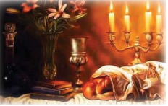

A Yid in Arad [in Israel], who gives shiurim to non-frum people who want to be mechazek in Yiddishkeit, said over the following amazing story: One day, he was giving a shiur on hilchos Shabbos. There was a person there who was very inspired and said he works seven days a week in a hotel.
He decided to tell his boss that he wants to work only six days a week. His boss told him, "Sorry. The job is seven days a week or there is no job." With that he was fired! He now had no job and no money to feed his wife and children.
He went home and took out the tefillin that he got for his bar mitzvah and he started davening to Hashem to send him parnassa (a livelihood). He did some hishtadlus (human efforts) and sent out his resume for a new job.
Two days later, he got a call from a hotel that wanted him. The job was not a six-day job though. Oh no!! Oh no? Oh YES! It was a five-day job!! Hashem saw his mesiras nefesh and heard his teÞllos and got him a job with an even better agreement than before! All in the zechus that he wanted to keep Shabbos! [Kav Hashgacha Pratis] Yes! Klal Yisrael loves Hashem! Yes! Hashem loves Klal Yisrael! And Yes! Our nation is as stunning as ever!

Reprinted from the Parshas Va’eschanan 5782 edition of The Spring Hill Times.

The Attraction to
Watch Movies
By L.G.

My teenage son, despite learning strongly in [a Jerusalem] yeshiva, found himself ‘good’ friends who persuaded him to watch movies. Once it started it was hard for him to stop, and he looked for any opportunity to go places to watch movies.
Of course, over time he asked me to allow him to watch movies in the house so that he would not watch outside because then he would be exposed to the wrong content, and he preferred to protect himself and not fall to even worse things…
I explained to him that in our house we do not watch movies, neither me or anyone else, and the computer is fully protected and is only used for work, and no persuasion would do any good to bring movies into the house for him.
The boy did not give up and continued to press with claims that there was supervision in the house and outside he might fall into worse things. Until an idea popped into my head: “Go to our Rebbe and tell him the matter, and if I receive an order from him, then I will immediately do as he says and bring everything he tells me into the house!!!”
The next day the boy showed up at the Rebbe’s house and presented his arguments. Of course, the Rebbe tried speaking to his heart and explain to him the seriousness of the matter, and why we came into the world, and he asked him to learn books of mussar, which had the power to kill the power of the yetzer hara. He added that it would better to pray to go blind and not sin chalilah.
But all these words fell on deaf ears. We left the Rav’s house and my son left me holding the sefer the Rav gave him, he continued on his way as if nothing happened. I dropped him off at the stop for the yeshiva. I davened to Hashem that He enlighten the correct way for me.
Suddenly, I did some soul searching as I myself walk around with a kosher, filtered device that I use for work, but I get news headlines and movie reviews on it. True, everything is kosher and clean, but if I do not control myself, how can I ask the boy to be pure when I am flawed?!
It was hard but I took upon myself not to be updated at all during The Three Weeks until after Tisha B’Av, which means not to look at friends’ devices… This is very hard for someone who has no other way to keep up with news in the world but I took this on because of the boy.
That week, on Motzaei Shabbos, the boy told me that he wanted to let the Rebbe know that he took on not to watch movies until Tishrei, even though this was very hard to take this on himself!!!
All the speeches did not help, just one acceptance by the father helped immediately. I publicize the story to inform parents that instead of yelling and being frustrated, each person should examine himself for a flaw that he is asking his child to correct. Even bain hazmanim remember that the apple does not fall far from the tree.

Reprinted from the Parshas Vaeschanan 5782 email of Tiv Hakehila.
High Honor
By Rabbi Shimon Finkelman and
Rabbi Zechariah Wallerstein

Rabbi Dovid Trenk excelled in every aspect of his avodas Hashem, including his kibbud av va’eim. When his mother worked in Manhattan, Rabbi Trenk would arrange his schedule so that he was in his car parked outside the subway station in Flatbush when his mother would get off the train after work.
Her home was within walking distance of the station, but that did not matter to Rabbi Trenk. He would not pass up the opportunity to drive his mother home.
On the morning of Erev Pesach, Rabbi Trenk’s father would open his dry goods store on the Lower East Side for those who needed to do last minute shopping. As a teenager, Rav Dovid would take the train from Brooklyn to Manhattan to bring his father some kosher l’Pesach food.
After Rabbi Trenk took ill in the fall of 5779, Rabbi Hillel Brull visited him. Rabbi Trenk had finished davening Shacharis and had removed his tefillin, but had not yet wound the retzuos, as is done before placing the tefillin in their velvet case.
He asked Rabbi Brull to wind them for him and explained why he could not do this himself.
“When I was 14 years old, my father z”l visited me at Camp Munk and saw that I was winding my retzuos while seated. He told me that not only should I put on and remove my tefillin while standing, but I should even wind the retzuos and put the tefillin away while standing. But today I don’t feel strong enough to stand anymore. So please wind the retzuos for me.”
Rabbi Brull responded, “Rabbi Trenk, I am sure that your father would be mochel if you sat this time while winding your retzuos.”
“It’s not a question of being mochel,” said Rabbi Trenk. “All his life, my father never raised his voice to me, never displayed any anger. But I still want to do it the way he told me. So please do it for me.”
When Rabbi Trenk’s sons had become bar mitzvah, he taught them the way his father taught him, to wind their retzuos while standing.

Reprinted from the Parshas Va’eschanan 5782 email of At the ArtScroll Shabbos Table. Excerpted from the ArtScroll book – “Honor Them, Revere Them” by Rabbi Shimon Finkelman and Rabbi Zechariah Wallerstein.

Danger to Health
By Rabbi Nosson Muller

Due to health reasons, Rav Yehoshua Leib Diskin was not allowed to have any salt in his food. Even a little salt could have a catastrophic effect on his wellbeing. One day during shiur, he asked a student to bring him a glass of hot tea in order to ease his sore throat.
Erroneously, the student mistook the salt for the sugar and put two heaping spoons of salt in the tea instead of sugar!
Rav Yehoshua Leib drank the tea as if nothing was wrong despite the horrible taste and danger to his health. A few minutes later, his wife, who had noticed the salt
container out on the counter and realized what happened, came frantically running to the shiur room and motioned to her husband to come out of the shiur.

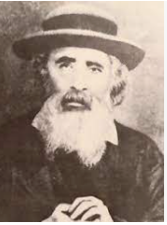
Rav Yehoshua Leib Diskin

“Did you drink the tea? There was salt in it!” she exclaimed.
“How could l not?” was Rav Yehoshua Leib’s answer.
“What do you mean?” his wife said. “Your health is in danger!”
The rav answered, “It might be detrimental to my health, but my not drinking that cup of tea would have been an embarrassment to that boy who made the tea. That would be like killing him and that I could not do, regardless of my health!”

Reprinted from the Parshas Va’eschanan 5782 email of At the ArtScroll Shabbos Table. Excerpted from the ArtScroll book “Pirkei Avos: Generation to Generation” by Rabbi Nosson Muller.

The Woman’s Prayers for Burial
In the Old Krakow Cemetery

The Klausenberger Rebbe zt'l heard the following story from his father, Reb Tzvi of Rudnik zt'l: There are two cemeteries in Krakow (Poland). In the older cemetery are buried many ancient scholars, such as the Bach, the Megaleh Amukos, and the Rema.
A local Krakow woman wanted to be buried in the older cemetery, but that was almost impossible. For hundreds of years, no one had been buried in the old cemetery. Even the rabbanim of Krakow were buried in the new cemetery.
But this woman didn't give up. Three times a day, by shacharis, minchah, and maariv, she came to the beis knesses and davened that Hashem have compassion on her, and she be buried in the old cemetery. She was so obsessed with this desire that all children in Krakow knew to greet her, "Good morning, aunt. May you be buried in the old cemetery."
This is what she trained them to say. At the weddings of her children, grandchildren, and great-grandchildren, she would ask the chasan and kallah to bless her that she be buried in the old cemetery. It was really insane because why was this so important to her?

Photo of the historic Old Cemetery in Krakow, Poland

Furthermore, it was almost impossible to be buried in the old cemetery. But she was stubborn with her wish. On the day she left the world, there was a heavy snowstorm and snow piled high on the ground. The chevrah kadisha couldn't carry her to the new cemetery, so she was buried in the old cemetery.
Reb Tzvi of Rudnik commented about this story, "This taught me that even when one davens for something insane, Hashem will listen to his tefillos and answer them. So great is the power of tefillah!"

Reprinted from the Pinchas 5782 email of Torah Wellsprings: Collected Thoughts from Rabbi Elimelch Biderman.

The Father of All Contemporary Sephardic Kabbalists

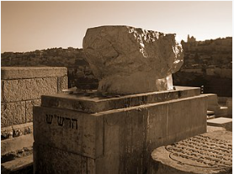
Tombstone of Rabbi Shalom Sharabi on the Mount of Olives in Jerusalem

Rabbi Shalom Sharabi -- The Rashash - is considered the father of all contemporary Sephardic kabbalists. Rabbi Sar-Shalom Mizrachi Didia ben Yitzchak Sharabi, known as the "Rashash" [initials for "Rabbi Shalom Sharabi"], was born in 5480 (1720) in Sana'a, the capital of Yemen.
After being miraculously saved from a difficult situation, he fulfilled his vow to go to the Holy Land of Israel in order to live in Jerusalem. After a journey that led him through India, Baghdad and Damascus, he arrived in Jerusalem. ...he was determined to keep his abilities hidden in the Holy Land.

Hoped to Keed His Torah and Kabbala Scholarship a Secret
Although he had already established himself in his previous countries of residence as a significant Torah scholar and Kabbalist, he was determined to keep his abilities hidden in the Holy Land.
He approached Rabbi Gedalia Chayon, the head of Beit El Yeshiva, the major center for Kabbalah study, and applied for the job of shammash (caretaker). All he asked for in return was a roof over his head and some food. The headmaster took pity on the young orphan and gave him the job. In this way he was able to stay anonymous yet quench his thirst for Torah.
His official job was to wake up the students for the Midnight Rectification Prayer, keep the shelves of holy books in order, bring water and serve hot tea. This enabled him to stand innocently in the corner during lessons as if he was not part of the privileged group of students [which included the famed Chidah], yet he was listening intently.

An Extremely Difficult Question Arose
No one dreamed that this simple shammash was actually a great scholar. Once, an extremely difficult question arose which no one could solve. Young Shalom noticed Rabbi Gedalya's disappointment and that evening, after all the students left, he wrote down what he knew to be the answer and inserted the note into one of the Rosh Yeshiva's books.
The next day Rabbi Gedalya was delighted, "A note from G-d," he thought. But after this act was repeated a few times, Rabbi Gedalya realized it must be one of his students. He proclaimed, "I decree that the writer of these notes should reveal himself and that we will allot him the respect he deserves."
For the sake of modesty and his desire to stay anonymous, Rabbi Shalom still did not confess, so the issue remained a mystery. Chana, the daughter of the Rosh Yeshiva, realized how much her father wanted to find out who was the individual leaving the notes. She decided to spy at nights through the window. Finally, one night she saw the Rashash sticking a paper inside a book on the Rosh Yeshiva’s desk. She immediately notified her father.
The Rashash was forced to admit to him his authorship. He pleaded to be allowed to remain hidden, but Rabbi Gedalia took his daughter’s discovery as a sign from Heaven that it was time for the Rashash to be revealed. After Rav Gedalia’s death in 5507 (1747), the Rashash, then only 27 years old, was appointed Rosh Yeshiva, according to Rabbi Gedalya's dying wish. He was already married to Chana, with a son whom they named Yitzchak. Among his students were the Chidah, and the Maharit Algazi who became the Rosh Yeshiva after the passing of the Rashash.

Authored a Major Commentary on the Etz Chaim
He wrote a commentary on the Etz Chaim of which Rav Yeddiya Abulafia said that whoever learns Etz Chaim without the commentary of the Rashash is like a blind man feeling his way in the dark. Among his most famous writings is the Siddur HaRashash, known for its special Kabbalistic intentions for prayer, which has become the standard for all [Sephardic] Kabbalists today.
The Rashash passed on to his heavenly reward on the 10th day of the Jewish month of Shevat, in the year 5537 (1777) at the age of 57, in Jerusalem. He is buried on the Mount of Olives, where his grave is a pilgrimage site until this day. The great Kabbalist, Rabbi Chaim Pelaji, testified that Rabbi Shalom Sharabi's soul was that of the holy Ari of Tzefat. Rabbi Yitzhak Kaduri used to say, "One can have memorized all of the written teachings of the Ari, and have studied them and the commentaries upon them in great depth, but "...if you have not learned the works of the Rashash, you have not yet entered into the study of Kabbalah." He is considered the father of all contemporary Sephardic kabbalists. [By Rabbi Yerachmiel TillesChabad.org]

Reprinted from the Parshat Eikev 5782 email of R’ Yedidye Hirtenfeld’s parshasheet whY I Matter for the Young Israel of Midwood in Brooklyn.

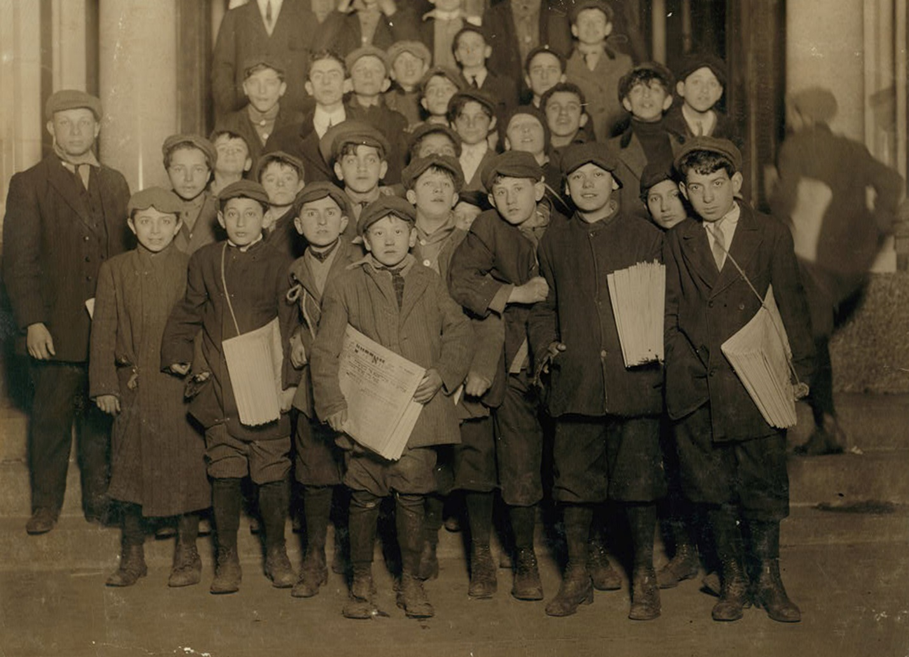

Waiting for the “Forwards”, 1913. Photograph by Lewis Wickes Hine. Library of Congress, Prints and Photographs Division.

